

March 2026 Newsletter

Inside This Issue:
Page 1: Welcome to our newsletter and Abuse is not tolerated
Page 2: Breast Cancer Now Support Group
Page 3: Measles Cases rising in parts of England
Page 4: Under 16s Proxy Access
Page 5: Prostate Cancer Awareness Month

Welcome to the Ancora Medical Practice Newsletter
We’re excited to bring you our newsletter! Whether you’re a long-time patient or have recently joined our practice, this newsletter is a great way to keep informed with our most recent information.

Abuse is not tolerated at Ancora Medical Practice

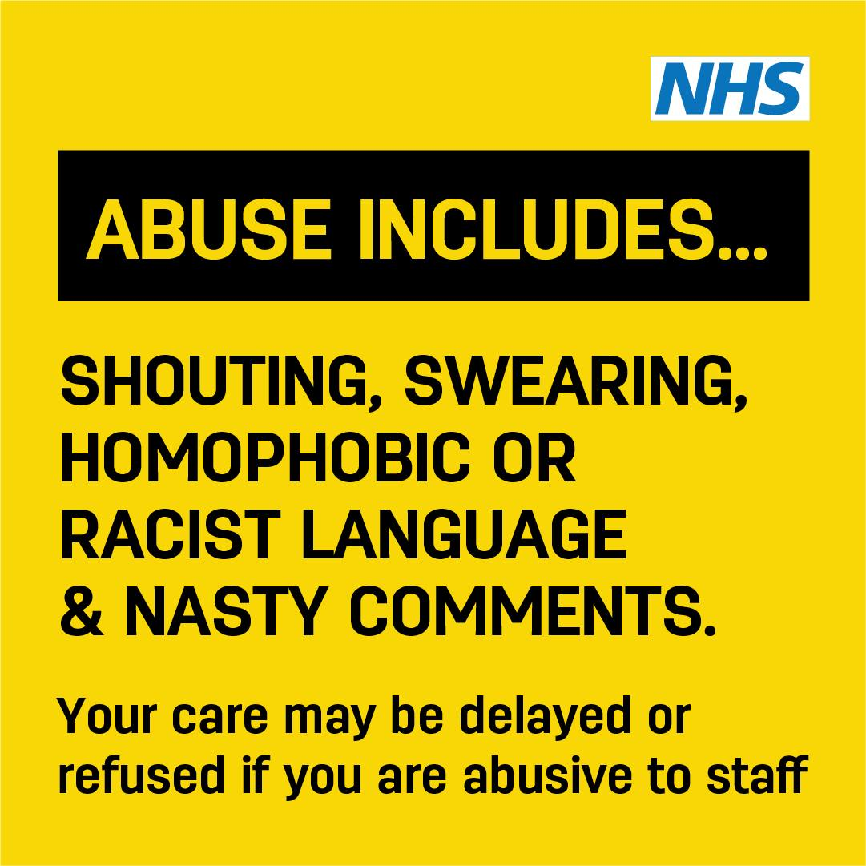

Breast Cancer Now Support Group

Breast Cancer Now runs a support group for people living with secondary breast cancer in North Lincolnshire. They share “We know a diagnosis of secondary breast cancer can mean adjusting to difficult changes in your life, and sometimes it can help to talk with other people in a similar situation. Our free Living with Secondary Breast Cancer group in North Lincolnshire gives you the chance to do just that, in a relaxed and supportive environment. Details for our group:
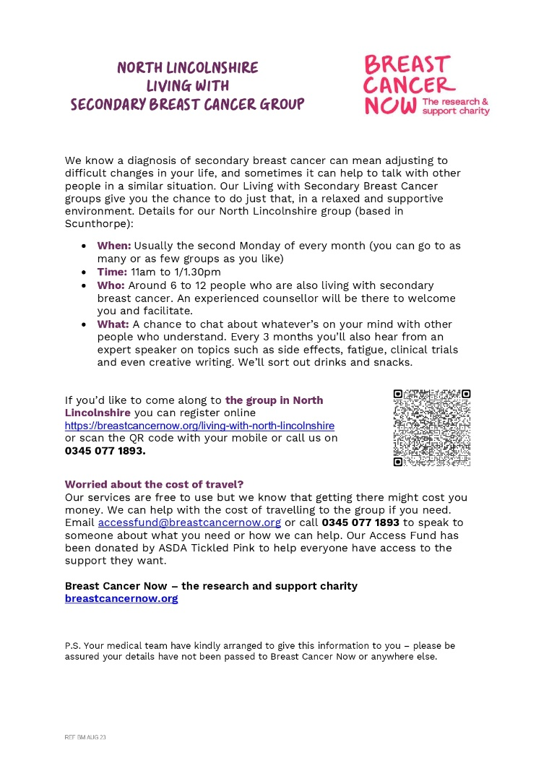
Where: Scunthorpe town centre
When: Usually the second Monday of every month
Time: 11 am to 1 pm
Who: Around 5 to 15 people and an experienced counsellor will be there to welcome you and facilitate
If you’d like to come along you can register online Register for Living with Secondary Breast Cancer | Breast Cancer Now or call us on 0345 077 1893”
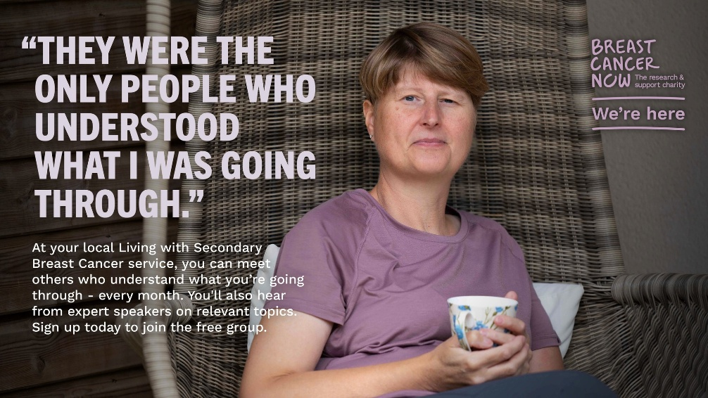

Measles Cases are rising in parts of England

We are seeing a rise in measles cases in parts of England.

Vaccination is the most effective way to protect children from serious illness.
We’re encouraging parents to check their children are up to date with their vaccinations. Check your child's red book or speak to their GP practice.
For more information, please scan QR code to visit the information page for MMR

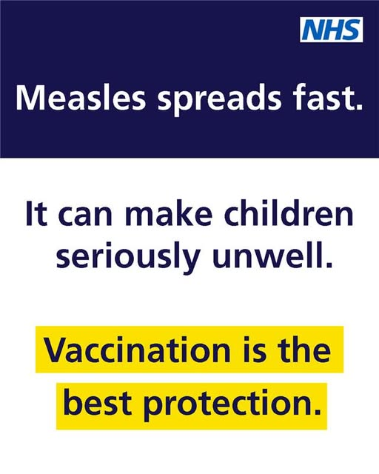

Information for under-16s on parents and guardians access your medical records
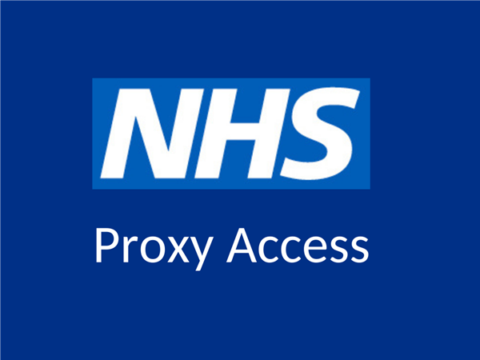
Your parent or someone else that looks after you may want to use apps or websites to:
- see, book and cancel appointments for you
- see and order prescriptions for you when you need medicine
- look at your health record online
They can ask your doctors (your GP surgery) to link your NHS profile to theirs, so they can do this for you. This is sometimes called "parent and guardian proxy access", or "third party access".
It lets them manage your health and care for you online while you're growing up, until you're old enough to do it on your own.
Scan the QR code below to gain further information or if you wish for further information, you can contact the surgery.


Prostate Cancer Awareness Month

March is Prostate Cancer Awareness Month.

It’s important to know the signs and symptoms – especially as risk increases with age. Most cases develop in men aged 50 or older and prostate cancer is more common in Black men.
Prostate cancer often develops slowly, so there may be no symptoms for many years.
Early diagnosis and treatment can save lives. Contact your GP if you notice any changes in your body or something doesn’t feel right.
Find more information on prostate cancer. https://www.nhs.uk/conditions/prostate-cancer/
